Tester Lab - Using a Multimeter and a Power Supply
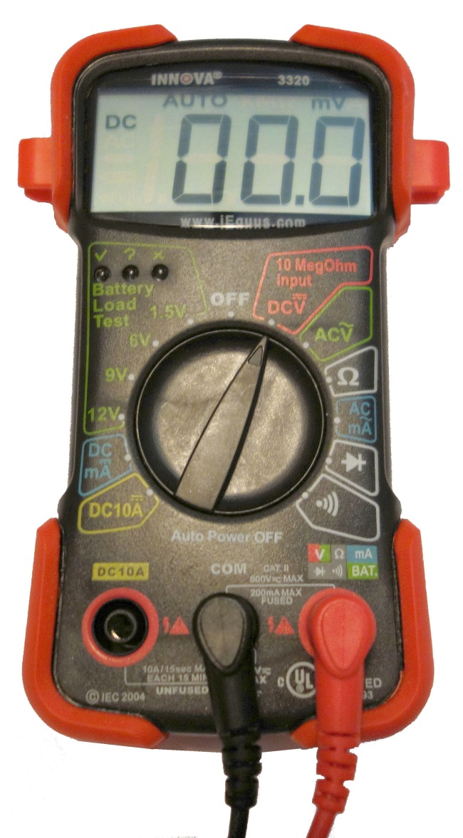
Introduction
In this lab, you will learn how to use and handle a multimeter and a power supply tester.
Recommended Equipment
- A digital multimeter
- The multimeter manual
- A battery to test
- A power supply tester
- A manual for the tester
- A power supply
Note: The multimeter is a sensitive piece of electronic test equipment. Do not drop it or handle it carelessly. Be careful not to accidentally nick or cut the red or black wires or leads, called probes. Because it is possible to check high voltages, take extra care to avoid electrical shock.
- Multimeter
  - Set up the multimeter.
    - Insert the red and black leads into the jacks on the meter. The black probe should go in the COM jack and the red probe should go in the + (plus) jack.
    - Turn on the multimeter (consult the manual if there is no ON/OFF switch).
What is the model of the multimeter?
____________________________________________________________________________________
What action must be taken to turn the meter on?
____________________________________________________________________________________
  - Explore the different multimeter measurements.
    - Switch or turn to different measurements. For example, the multimeter can be adjusted to measure Ohms.
How many different switch positions does the multimeter have?
____________________________________________________________________________________
What are they?
____________________________________________________________________________________
    - Switch or turn the multimeter to the DC voltage measurement.
What symbol is shown for this?
____________________________________________________________________________________
  - Measure the voltage of a battery.
    - Place the battery on the table. Touch the tip of the red (positive) probe to the positive (+) side of a battery. Touch the tip of the black (negative) probe to the other end of the battery.
What is shown on the display?
____________________________________________________________________________________
____________________________________________________________________________________
If the multimeter does not display a number close to the battery voltage, check the multimeter setting to ensure it is set to measure voltage, or replace the battery with a known good battery. If the number is negative, reverse the probes.
    - Name one thing you should not do when using a multimeter.
____________________________________________________________________________________
____________________________________________________________________________________
    - Name one important function of a multimeter.
____________________________________________________________________________________
____________________________________________________________________________________
    - Disconnect the multimeter from the battery. Switch the multimeter to OFF. Part 1 of the lab is complete. Have your instructor verify your work.
Why is a digital multimeter an important piece of equipment for a technician? Explain your answer.
____________________________________________________________________________________
____________________________________________________________________________________
____________________________________________________________________________________
- Power Supply Tester
Complete only the steps for the connectors supported by the power supply tester that you are using.
  - Check the testing ports for the power supply tester.
Many power supply testers have connector ports to test the following power supply connectors:
- 20-pin/24-pin motherboard connector
- 4-pin Molex connector
- 6-pin PCI-E connector
- P4 +12V connector
- P8 +12V EPS connector
- 4-pin Berg connector
- 15-pin SATA connector
Which connectors does the power supply tester you are using have?
_______________________________________________________________________________________
  - Test the power supply motherboard connector.
Complete the following steps for the connectors supported by the power supply tester that you are using.
    - Set the power supply switch (if available) to the OFF (or 0) position.
    - Plug the 20-pin or 24-pin motherboard connector into the tester.
    - Plug the power supply into an AC outlet.
    - Set the power supply switch (if available) to the ON (or 1) position.
If the power supply is working, LEDs will illuminate and you might hear a beep. If the LED lights do not illuminate, it is possible the power supply could be damaged or the motherboard connector has failed. In this instance, you must check all connections, ensure the power supply switch (if available) is set to ON (or 1) and try again. If the LEDs still do not illuminate, consult your instructor.
Possible LED lights include +5 V, -5 V, +12 V, +5 VSB, PG, -12 V, and +3.3 V.
Which LED lights are illuminated?
____________________________________________________________________________________
  - Test the power supply Molex connector.
Plug the 4-pin Molex connector into the tester. The LED illuminates on +12 V and +5 V. (If the power output fails, the LEDs will not illuminate.)
Which LED lights are illuminated?
_______________________________________________________________________________________
  - Test the 6-pin PCI-E connector.
Plug the 6-pin PCI-E connector into the tester. The LED will illuminate on +12 V. (If the power output fails, the LED will not illuminate.)
Does the LED light illuminate?
_______________________________________________________________________________________
  - Test the 5-pin SATA connector.
Plug the 5-pin SATA connector into the tester. The LED will illuminate on +12 V, +5 V, and +3.3 V. (If the power output fails, the LEDs will not illuminate.)
Which LED lights are illuminated?
_______________________________________________________________________________________
  - Test the 4-pin Berg connector.
Plug the 4-pin Berg connector into the tester. The LED will illuminate on +12 V and +5 V. (If the power output fails, the LEDs will not illuminate.)
Which LED lights are illuminated?
_______________________________________________________________________________________
  - Test the P4/P8 connectors.
    - Plug the P4 +12 V connector into the tester. The LED will illuminate on +12 V. (If the power output fails, the LEDs will not illuminate.)
    - Plug the P8 +12 V connector into the tester. The LED will illuminate on +12 V. (If the power output fails, the LEDs will not illuminate.)
Which LED lights are illuminated?
____________________________________________________________________________________
    - Switch the power supply to OFF (or 0) if available. Disconnect the power supply from the AC outlet. Disconnect the power supply from the power supply tester. The lab is complete. Have your instructor verify your work.
Why is a power supply tester an important piece of equipment for a technician? Explain your answer.
____________________________________________________________________________________
____________________________________________________________________________________
____________________________________________________________________________________

